The NMAPC “Yellow Card” Advantage

Below is a brief description of the benefits and advantages afforded owners, contractors, and construction managers that use the NMAPC “Yellow Card” system.

There are two types of “Yellow Card” designation, the “Yellow Card” site and the “Yellow Card” project. The “Yellow Card” site is a designation that can only be used by owners, but the “Yellow Card” project designation can be used by owners, contractors, or construction managers.

So, what is a NMAPC “Yellow Card” site? Simply put, an owner is agreeing to do all of their industrial maintenance work at a given facility or site under the terms of the NMA in return for various benefits and assurances afforded them under the NMAPC program.

The actual yellow card (Below) is simply bid specification language to include for projects, or ongoing maintenance activities, at an owners’ facilities. However, being covered as a “Yellow Card” site entails much more than just following a bid procedure.

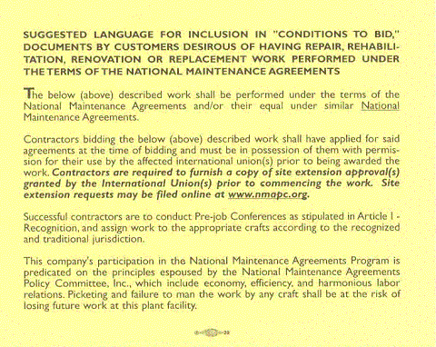

As a designated “Yellow Card” site an owner is granted certain privileges, if you will, under the NMAPC program. For one, an owner can expect more interaction with the Committee. This would include on-site seminars on the use of the NMA’s and free guidance on NMA related Labor Relations issues, not just for the owner, but for your contractors as well.

Also, an owner is provided extra protection relative to any potential job action that might occur at their facility. If designated a “Yellow Card” site, in the unlikely event that a job disruption occurs the owner will receive the following extra protections: 1) Once the NMAPC administrative office is notified of the incident in writing, a hearing will be held in Washington, D.C. within 24 hours to determine if there has in fact been a violation of the Agreement; 2) A decision will be rendered by our permanent arbitrator within 3 hours of the hearing; 3) If it is found that an illegal job disruption has taken place, fines will be levied against any and all crafts participating in the job disruption; 4) Any fines levied will be retroactive to the beginning of the job action, and the fines would be $10,000 for the first shift and $40,000 per each additional shift, per craft, payable to the owner. While these fines may not be of epic proportions to a large owner, they are a huge amount to local unions, and have proven to be a deterrent from any job action that might occur.

If making an entire site “Yellow Card” is simply not feasible, or if contractors and construction managers desire the benefits of the “Yellow Card” system, consideration should be given to requesting the “Yellow Card” project designation. Using the “Yellow Card” designation for certain projects affords an owner, contractor, or construction manager many of the same benefits and protections that the designation as a “Yellow Card” site would, but covers only a certain scope of work instead of an entire facility. The only distinct difference in protection between a site and a project designation is the fine amount. The fines levied for a “Yellow Card” project are $10,000 for the first shift and $20,000 per each additional shift, per craft, payable to the requesting party.

The “Yellow Card” designation is something that benefits all three parties that participate in the NMAPC program. The crafts are guaranteed work at a given facility; contractors benefit from continuity of work, and owners get added protection and more engagement from the NMAPC.

Also, keep in mind that this designation is of no cost to the owner, and of no additional cost to NMA signatory contractors, it simply requires a commitment from the company to perform maintenance work under the NMA.

If you are interested in having your facilities, or projects, designated as “Yellow Card”, please contact our office directly so that we can address your request in an expeditious and professional manner.

